Volunteers Needed on April 27th
COME OUT AND MAKE A DIFFERENCE!
HELP AND KEEP YOUR COMMUNITY CLEAN

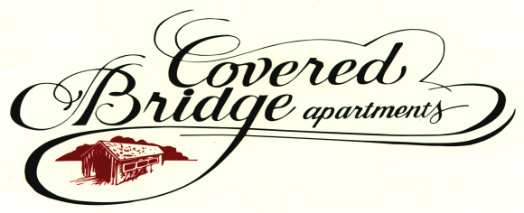

4909 Covered Bridge Rd.
Indianapolis, IN 46268
Office (317) 293-9926 (Simon)
Fax (317) 293-9927

It’s time for our 3rd year in “Keeping Indianapolis Beautiful” event on Saturday, April 27, 2013 at Covered Bridge Apartments.

- Sign in at 8:30am-9:15am and receive a team captain t-shirt, gloves, trash bags, bottle water and instructions on the lunch celebration and early-bird raffle tickets.
- At 9:15am kick off! Let’s walk and pick up trash!!! It’s Easy, Everyone can participate.
- Return to Covered Bridge Office at 10:30am for testimony from 2012 Rev- Up participant, an update on “Why, Where & How” to serve by United Way Representative.
- 11:00am Food and Celebration, visit vendor tables and Raffle prize give away by Covered Bridge Staff.
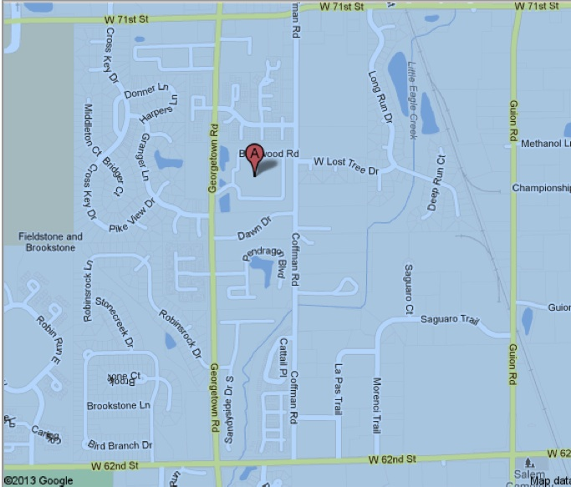

Convening Organization

